|  |  |  |
| --- | --- | --- |
| **MODULE:** 12 | **LESSON:** 1 | GRAPHING ON THE COORDINATE PLANE |

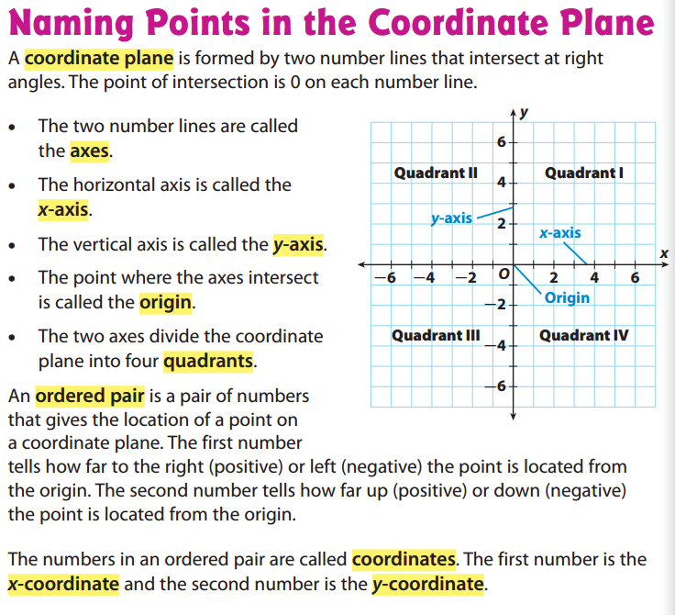

*An ordered pair gives the location of a point on a coordinate plane. The first number tells how far to move right (positive) or left (negative) from the origin. The second number tells how far to move up (positive) or down (negative).* ***REMEMBER: YOU HAVE TO WALK BEFORE YOU CAN CLIMB!***

*The numbers in an ordered pair are called coordinates. The first number is called the x-coordinate. The second number is called the y-coordinate.* ***(x,y)***

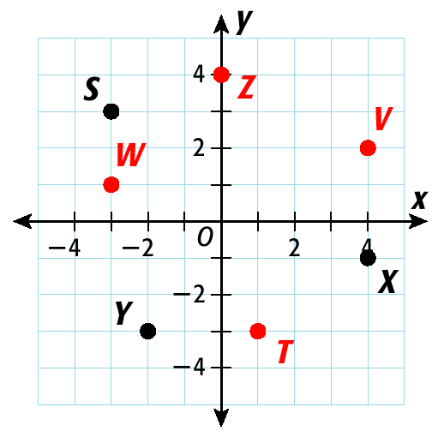

***Z is (0,4)***

***V is (4,2)***

***W is (-3,1)***

***S is (-3,3)***

***Y is (-2,-3)***

***T is (1,-3)***